### **Lab Guide: Amazon S3 Activities Using AWS CLI (Windows & Linux/Mac)**

## **Objective**

This lab provides step-by-step instructions to perform multiple activities on Amazon S3 using AWS CLI, including:

1. Creating an S3 bucket.
2. Uploading a file to the bucket.
3. Listing bucket contents.
4. Downloading a file from the bucket.
5. Deleting a file from the bucket.
6. Enabling versioning.
7. Deleting the bucket.

**Reminder:** Ensure the AWS CLI user has the necessary **S3 permissions** attached to their IAM role or user. The required permissions include:

{

"Version": "2012-10-17",

"Statement": [

{

"Effect": "Allow",

"Action": "s3:*",

"Resource": "arn:aws:s3:::*"

}

]

}

Attach this policy or a more restrictive version to the IAM user before proceeding.

## **Prerequisites**

1. **AWS Account**: Ensure you have access to an AWS account.
2. **AWS CLI Installed**: Download and install AWS CLI from [AWS CLI Download](https://aws.amazon.com/cli/).
3. **AWS CLI Configured**: Run aws configure and set up your AWS credentials.
4. **IAM User Permissions**: Ensure the IAM user has full S3 permissions (as noted above).

## **Part 1: Create an S3 Bucket**

### **Windows (Command Prompt or PowerShell) & Linux/Mac (Terminal)**

1. Open a terminal or command prompt.
2. Run the following command to create an S3 bucket:

aws s3api create-bucket --bucket my-cli-s3-bucket --region us-east-1 --create-bucket-configuration LocationConstraint=us-east-1

1. Replace my-cli-s3-bucket with a unique bucket name.
2. Verify the bucket creation:

aws s3api list-buckets

1. Ensure your bucket appears in the list.

**Summary:** In part 1, an S3 bucket must be created. An S3 bucket is created by running the following command with a unique bucket name in the command prompt. Bucket creation is then verified once after it is made. After verification, the bucket has to appear in the list as attached above.

## **Part 2: Upload a File to the Bucket**

### **Windows (Command Prompt or PowerShell)**

1. Create a sample file:

echo "Hello S3" > myfile.txt

1. Upload the file to S3:

aws s3 cp myfile.txt s3://my-cli-s3-bucket/



### **Linux/Mac (Terminal)**

1. Create a sample file:

echo "Hello S3" > myfile.txt

1. Upload the file to S3:

aws s3 cp myfile.txt s3://my-cli-s3-bucket/

1. Confirm the upload:

aws s3 ls s3://my-cli-s3-bucket/



**Summary:** After the bucket has been created, a file must be uploaded to it. To do that, a sample file is first created by the name ‘awssamplelab3b’. This sample file is then uploaded to the S3.

## **Part 3: Download a File from the Bucket**

### **Windows, Linux, and Mac**

1. Download the file back to the local system:

aws s3 cp s3://my-cli-s3-bucket/myfile.txt downloaded-file.txt

1.   
   Check the file contents:

  
type downloaded-file.txt # Windows

cat downloaded-file.txt # Linux/Mac



**Summary:** In the previous step, the file is uploaded to the S3. In this step, the file is downloaded to the local system. Components of the file have been checked once after it is downloaded. It can be observed that the file is downloaded from the above attachment.

## **Part 4: Delete a File from the Bucket**

1. Remove the uploaded file:

aws s3 rm s3://my-cli-s3-bucket/myfile.txt

1. Verify the file is deleted:

aws s3 ls s3://my-cli-s3-bucket/



**Summary:** A file has been created, uploaded in S3, and then later downloaded to the local system. Now, the file must be deleted to avoid unnecessary charges. Hence, the file is deleted from the bucket. File deletion and its verification are attached above.

## **Part 5: Enable Versioning on the Bucket**

1. Enable versioning:

aws s3api put-bucket-versioning --bucket my-cli-s3-bucket --versioning-configuration Status=Enabled

1. Verify versioning status:

aws s3api get-bucket-versioning --bucket my-cli-s3-bucket

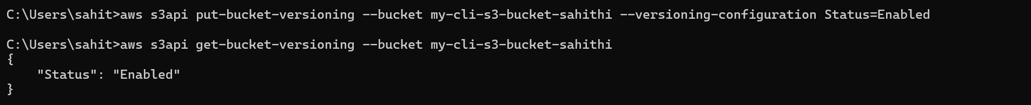

1.   
   Re-upload a new version of the file:

  
echo "Updated Content" > myfile.txt

aws s3 cp myfile.txt s3://my-cli-s3-bucket/

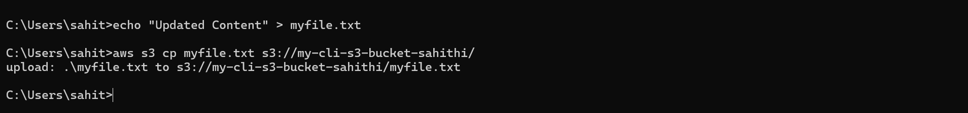

1.   
   List file versions:

aws s3api list-object-versions --bucket my-cli-s3-bucket



**Summary:** Here, versioning is enabled on the bucket by using the above-mentioned commands. Enabling versioning generally helps manage multiple versions of an object. It provides data security and recovery. After the versioning is enabled, its status is also verified just for confirmation. A new version of the file is uploaded without replacing the old one. Now, all the versions of the file are displayed with the Version id.

## **Part 6: Delete the Bucket**

**Important:** Ensure the bucket is empty before deleting.

1. Remove all files (including versions):

aws s3 rm s3://my-cli-s3-bucket –recursive



1. Delete the bucket:

aws s3api delete-bucket --bucket my-cli-s3-bucket --region us-east-1

1. Verify the bucket is deleted:

aws s3api list-buckets



**Summary:** The last step is to delete the bucket and check if it is deleted entirely.

**Challenges faced:**

The main challenge was the deletion of the bucket in part 6. Versioning was enabled due to which multiple versions of the files would be available. Since the versioning was enabled, removing the files with a single command was not enough. So, all the versions must be checked manually and then deleted. Later, markers are also deleted. After manually deleting these, the bucket is deleted using CLI.

## **Deliverables**

1. **Screenshots of:**
   * Bucket creation.
   * File upload and retrieval.
   * File deletion.
   * Versioning enabled and file versions listed.
   * Bucket deletion confirmation.
2. **Summary Report:**
   * Describe each step performed.
   * Mention any challenges faced and solutions applied.